**Sustainable Outreach And Universal**

**Leadership (SOUL) Limited**

**The Software Requirements Specification(SRS) is one of the first phases of system development. This phase results in the Software Requirements Specification(SRS) document, which must contain a complete, concise, high-quality description of the system being considered.**

Software Requirement Document: Scholarship

Table of Content

A. Abstract 3

B. Introduction 3

Purpose 3

Scope 3

1. Eligibility Criteria 3

2. Scholarship Types 3

3. Application Process 3

4. Selection Criteria 3

5. Scholarship Management 3

C. Definition, Acronyms and Abbreviations 3

D. Overview of the Document : 4

E. Detailed requirement 4

F. Flowchart Description : 4

G. Overall Screens and Their Descriptions : 4

1. Scholarship 5

1.1 General Description: 5

1.2 Scholarship Screenshot: 5

1.3 Scholarship Field list: 5

1.4 Users: Roles and Permissions 6

2. Scholarship Application 6

2.1 General Description: 6

2.2 Scholarship Application Screenshot: 6

2.3 Scholarship Application Field list: 7

2.4 Users: Roles and Permissions 9

# Abstract

Software Requirements Specification (SRS) is one of the first phases of system development. This phase results in the Software Requirements Specification (SRS) document, which must contain a complete, concise, high-quality description of the system being considered.

# Introduction

## Purpose

This document covers the functional requirements for Scholarships Screen of the Education module in ERP Product.

## Scope

The scope of this requirement document includes:

**Eligibility Criteria**

This screen shall help categorize the scholarship applicants based on eligibility criteria , such as academic qualifications, financial need, or other relevant factors. It may also outline any specific restrictions or limitations on eligibility, such as residency requirements or enrollment in a particular program.

**Scholarship Types**

This screen will help maintain the different types of scholarships available through the program, such as merit-based, need-based, or program-specific scholarships.

**Application Process**

This screen will facilitate the steps involved in applying for a scholarship, including application submission, review, and scholarship approval. It would also maintain any required documentation, such as a 10Th Certificate, Income Certificate, Caste Certificate or Residence/Domicile Certificate, and any deadlines for submitting applications.

**Selection Criteria**

This screen will also facilitate the criteria used to select scholarship recipients, such as academic achievement, financial need, or demonstrated leadership. It will also provide any specific weighting or ranking of criteria regarding the selected applicants.

**Scholarship Management**

Using this screen, the administrators can manage the scholarship program including application tracking, review, and selection.

# C. Definition, Acronyms and Abbreviations

The following table explains the terms and abbreviations used in the document:

|  |  |
| --- | --- |
| **Abbreviation** | **Description** |
| SRS | Software Requirements Specification |
|  |  |
|  |  |
|  |  |

# D. Overview of the Document

In today’s world, education has become one of the most essential and expensive assets. Most high school pass outs look for financial assistance to pursue the career of their dreams that requires several years of education. In such a scenario, scholarships come up as the most desired form of financial aid.

This document captures the requirements for the scholarship application section in an ERP system. The scholarship is provided based on some criteria and those criteria are often verified in the form of documents and ID numbers. For the above mentioned purposes, this document envisions two screens. One will store the criteria and the other screen will facilitate students in the scholarship application process and as well as assist the authorities to shortlist the eligible and deserving candidates.

# Detailed requirement

Scholarships(need to be discussed)

# WSC Scholarship Flowchart

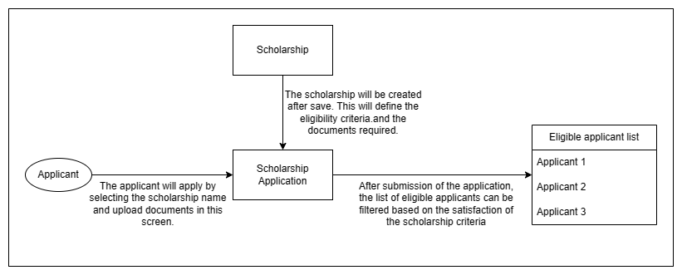

# Flowchart Description

**Scholarship:**

In the scholarship screen, the user will be maintaining all the required criteria and the documents names which are necessary for the scholarship application. This screen will be linked with the Scholarship Application screen and will facilitate the shortlisting of students eligible for scholarship.

**Scholarship Application :**

This screen will maintain the scholarship student applicants' records which will include their names, family income, documents, etc.

# Overall Screens and Their Descriptions

|  |  |  |
| --- | --- | --- |
| Sl no | Screen Name | Description |
|  | Scholarship | This is a master screen for Scholarship Application where the user can maintain the scholarship criteria and list of documents required for the scholarships. |
|  | Scholarship Application | The Scholarship Application screen will help the user maintain applications for eligible scholarship applicants which will be further used for review and selection process. |

1. Scholarship

## **General Description**

This is a master screen for Scholarship Application where the user can maintain the scholarship criteria and list of documents required for the scholarships.

The following table describes overall information about this screen:

|  |  |
| --- | --- |
| **Description** | 1. [Education Administrator](http://localhost:8000/app/permission-manager/Photocopy Application) user will select and add Scholarship Name.  2. [Education Administrator](http://localhost:8000/app/permission-manager/Photocopy Application) user will select and add Scholarship Company Name.  3. [Education Administrator](http://localhost:8000/app/permission-manager/Photocopy Application) user will select and add Basic Education criteria like 10th percentage, 12th percentage, etc.  4. [Education Administrator](http://localhost:8000/app/permission-manager/Photocopy Application) user will select and add Document template.  5. [Education Administrator](http://localhost:8000/app/permission-manager/Photocopy Application) user will select and add the start and end date for the scholarship applications.  6. [Education Administrator](http://localhost:8000/app/permission-manager/Photocopy Application) user will click the save and submit button and the record will be submitted. |
| **Navigation** | Home > Admission> Admission> Scholarship |
| **Pre-requisites** | The system should have records in the following screen   1. Scholarship Company 2. Academic Year 3. Document Template |

## Screenshot

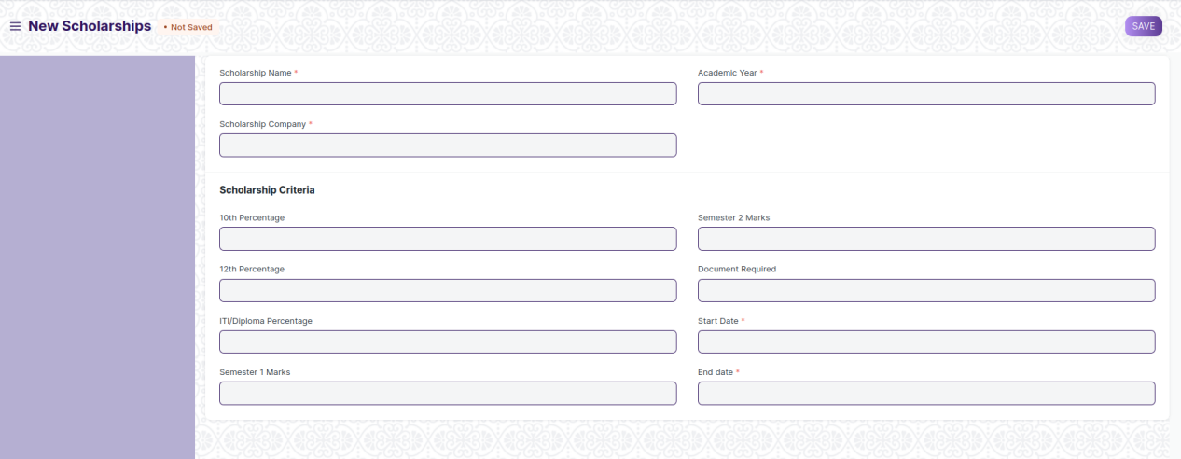

Figure 1: Scholarship Screen

## Field list

The following table describes the UI fields present on this screens:

|  |  |  |  |  |
| --- | --- | --- | --- | --- |
| 1. No. | Field Name | Field Type | Validation/Action | Mandatory |
| 1 | Scholarship Name | Text | User Input | Y |
| 2 | Scholarship Company | Link | Fetched from Company master | Y |
| 3 | Academic Year | Link | Fetched from Academic Year Master | Y |
| **Scholarship Criteria** | | | | |
| 4 | 10th Percentage | Percent | User Input |  |
| 5 | 12th Percentage | Percent | User Input |  |
| 6 | ITI/Diploma Percentage | Percent | User Input |  |
| 7 | Semester 1 Marks | Float | User Input |  |
| 8 | Semester 2 Marks | Float | User Input |  |
| 9 | Document Required | Link Field | Fetched from Document Template Master |  |
| 10 | Start Date | Date Picker | User Input | Y |
| 11 | End date | Date Picker | User Input | Y |

## Users: Roles and Permissions

The following table describes the users and their roles and permissions for the screens:

|  |  |  |  |  |  |  |  |  |  |
| --- | --- | --- | --- | --- | --- | --- | --- | --- | --- |
| ID | Role | Select | Read | Write | Create | Delete | Submit | Cancel | Amend |
| 1 | [Education Administrator](http://localhost:8000/app/permission-manager/Photocopy Application) | Yes | Yes | Yes | Yes | Yes | Yes | Yes | Yes |
| 2 | [System Manager](http://localhost:8000/app/permission-manager/Photocopy Application) | No | Yes | Yes | Yes | Yes | Yes | No | No |

1. Scholarship Application

## General Description

The Scholarship Application screen will help the user maintain applications for eligible scholarship applicants which will be further used for review and selection process. After submission of the application form on click of submit, the status of the application will be auto updated to eligible or not eligible based on the criteria of the scholarship selected, which was defined in the Scholarship master screen.

The Education Administrator user can now export the student records of all the eligible students in CSV/Excel format.

The following table describes overall information about this screen:

|  |  |
| --- | --- |
| **Description** | 1. Student user will select and add Scholarship ID and other related details like scholarship name and company name will be auto fetched.  2. Student user will select and add Student Name and other student details like Mobile number, family income, etc will be auto fetched.  3. Student user will select and add Basic Education Details which includes 10th, 12th percentages, course in which they have enrolled, and semester 1&2 marks.  4. Student user will select and add Parent’s Occupation.  5. Student user will select the Document Upload table and attach the required documents by selecting the document name from the drop down and then attaching it on click of Attach button.  6. Student user will select and add bank details.  7. Student user will click the save button and the records will be saved.  8.Finally, Student user will then submit for successful submission of records. |
| **Navigation** | Home > Admission> Admission> Scholarship Application |
| **Pre-requisites** | The system should have records in the following screen   1. Student applicant 2. Scholarship master records. |

## Screenshot

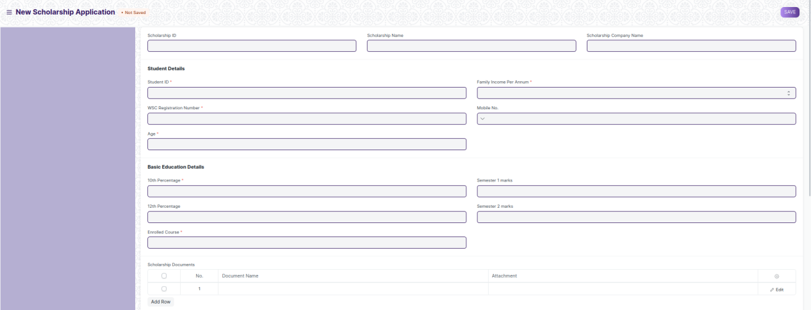

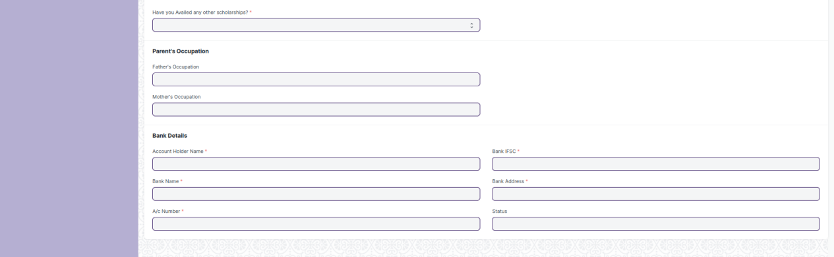

Figure 2: Scholarship Application Screen

## Field list

The following table describes the UI fields present in this screens:

|  |  |  |  |  |  |
| --- | --- | --- | --- | --- | --- |
| 1. No. | Field Name | Field Type | Validation/Action | Mandatory | Remarks |
| 1 | Scholarship ID | Link | Fetched From Master Screen Scholarship |  |  |
| 2 | Scholarship Name | Text | Auto Fetch Based on Scholarship ID |  |  |
| 3 | Scholarship Company | Text | Auto Fetch Based on Scholarship ID |  |  |
| 4 | Student ID | Link | Fetched From Master Screen Student | Y |  |
| 5 | Name of the Student | Text | Auto fetch based on Student ID |  |  |
| 6 | WSC Registration No. | Text | Auto Fetched From Master Screen Student | Y |  |
| 7 | Age | Number | Auto Fetched From Master Screen Student |  |  |
| 8 | Family Income per Annum | Drop Down | Below 1.25 Lakh  1.25 - 2.5 Lakh  2.5 - 3.5 Lakh  3.5 - 4.5 Lakh  4.5 - 5.5 Lakh  5.5 - 6.5 Lakh |  |  |
| 9 | Mobile Number | Phone | User Input, should not be more or less than 10 digits | Y |  |
| **Basic Education Details** | | | | |  |
| 10 | 10th Percentage | Percent | Auto Fetched From Master Screen Student | Y |  |
| 11 | 12th Percentage | Pecent | Auto Fetched From Master Screen Student |  |  |
| 12 | WSC Course Enrolled | Link | Fetched from Master screen Course |  |  |
| 13 | Semester 1 marks | Number | Auto Fetched From Master Screen Student |  |  |
| 14 | Semester 2 marks | Number | Auto Fetched From Master Screen Student |  |  |
| 15 | **Scholarship Documents** | Table |  | Y | Fields described in the table below |
| 16 | Have you Availed any other scholarships? | Drop down | Yes  No | Y |  |
| **Parent’s Occupation** | | | | |  |
| 17 | Father’s Occupation | Text | Auto Fetched From Master Screen Student |  |  |
| 18 | Mother’s Occupation | Text | Auto Fetched From Master Screen Student |  |  |
| **Bank Details** | | | | |  |
| 19 | Name of Account Holder | Text | User Input | Y |  |
| 20 | A/c Number | Number | User Input | Y |  |
| 21 | Bank Name | Text | User Input | Y |  |
| 22 | Bank IFSC | Text | User Input | Y |  |
| 23 | Bank Address | Text | User Input | Y |  |
| 24 | Status | Text | Auto updated based on the the Scholarship criteria |  |  |

|  |  |  |  |  |
| --- | --- | --- | --- | --- |
| **Scholarship Documents** | | | | |
| S. No. | Field Name | Field Type | Validation/Action | Mandatory |
| 1 | Document Name | Drop Down | 10Th Certificate  Income Certificate  Caste Certificate  Residence/Domicile Certificate |  |
| 2 | Attach | Attach Button | A dialog box will appear where the applicant will upload the required documents. |  |

## Users: Roles and Permissions

The following table describes the users and their roles and permissions for the screens:

|  |  |  |  |  |  |  |  |  |  |
| --- | --- | --- | --- | --- | --- | --- | --- | --- | --- |
| ID | Role | Select | Read | Write | Create | Delete | Submit | Cancel | Amend |
| 1 | [Education Administrator](http://localhost:8000/app/permission-manager/Photocopy Application) | Yes | Yes | Yes | Yes | Yes | Yes | Yes | Yes |
| 2 | [System Manager](http://localhost:8000/app/permission-manager/Photocopy Application) | No | Yes | Yes | Yes | Yes | No | Yes | No |
| 3 | [Student](http://localhost:8000/app/permission-manager/Photocopy Application)(Only if creator) | Yes | Yes | Yes | Yes | Yes | Yes | Yes | No |
| 4 | [Student](http://localhost:8000/app/permission-manager/Photocopy Application)(After Submission) | No | Yes | No | No | No | No | Yes | No |